**Project 1 – LAB 2 (LED Flasher)**

Required :

LED 1x

Resistor 220Ohm 1x

Board 1x

Jumper wires

Circuit :

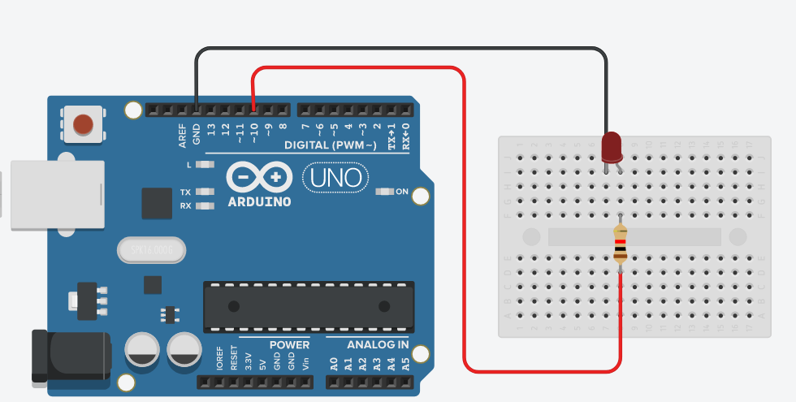

Code :

|  |
| --- |
| int LedPin = 10 ;  void setup() {  pinMode(LedPin , OUTPUT);  }  void loop() {  digitalWrite(LedPin , 1 ) ;  delay(1000);  digitalWrite(LedPin , 0 ) ;  delay(1000);  } |

LED ON :

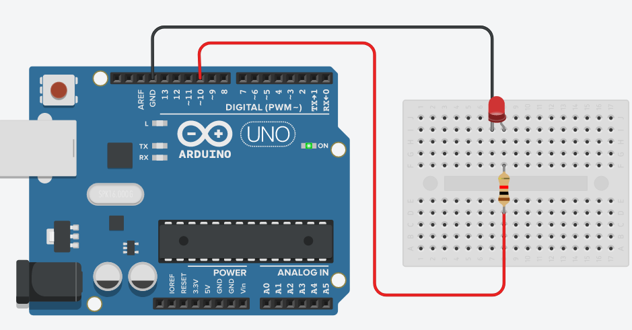

LED OFF :

